**Analysis:**

Based on the simulation that was made from the project, I have observed several things from the data that was calculated and what I had originally intended to do with the simulation. To begin, as mentioned in my presentation, several liberties and assumptions had to be made for the sake of simplicity and time for the simulation to work. Assumptions such as pressure and temperature not factoring into the calculations for the forces applied to the submarine, which in turn would affect the acceleration, velocity and displacement of the submarine. Similarly, other realistic variables such as realistic measurements for the submarine itself are not enforced, and space is considered in which the displacement of fluid when an object is submerged into water is not simulated.

When making the simulation, I found out about the Archimedes’ principle and decided to apply it to this simulation in an attempt to simulate how a submarine is able to control its buoyancy in order to submerge or surface in water. While making the simulation, it was found that Archimedes’ principle only considers the application of buoyant force from the fluid along with gravitational force, and not much else. This means that despite having implemented the calculation of net force with buoyancy and gravity, other forces like friction, pressure and temperature of the fluid that would affect the net force would not be considered and would therefore render the simulation not very realistic. Furthermore, the simulation was made to be very simplistic, visualizing only one-dimensional movement on a vertical axis just to show how it descends or ascends. In a realistic scenario, a submarine would usually move horizontally when it submerges or surfaces, also, a submarine would only be able to submerge so far before the integrity of its hull gets compromised by the pressure.

Regardless, in the simulation, I used an equation for simply calculating the net force by first calculating the buoyant force minus Newton’s 2nd law, which would return how much force is applied and whether the submarine would submerge or surface depending if the force applied was negative or not. Input variables such the submarine’s height, the submarine’s radius and submarine’s mass would be used to calculate for the submarine’s density and the submarine’s volume, which is what is used to calculate for the gravitational force applied. Fluid density is usually a constant but the simulation allows to set a custom value, by default, 1029 kg/m3 is the standard value for the density of sea water, which is what the simulation uses. Fluid density is used in the calculation of buoyant force. Values can also be inputted for the amount of water that the ballast tanks can take in, which controls how much density is added to the submarine, which in turn, determines how deep the submarine can dive and the speed in which it can do so. Finally, displacement can also be inputted in which the simulation can be started by placing the submarine at a certain depth. The simulation will then use the net force to calculate for the acceleration in which the submarine will descend or ascend at, which in turn uses that to calculate for velocity and displacement that occurs at that time step. Pictured below are the input values for the simulation.

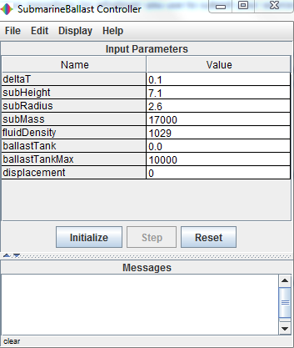

In order to verify the data produced by the simulation, a calculation of the net force at one time step must be made. First, we will assume certain input values for the simulation, we’ll start with the initial values pictured above, but instead of 0.0 for the amount of water in the ballast tanks, a value of 1000 will be used. First, we need the values for things such as submarine density and submarine volume. We can find submarine volume by using the dimensions in the equation pi*r2*h, which gets us 150.7044 for submarine volume. We then use this in the calculation for the submarine density, by taking the submarine mass and dividing it by the submarine volume (17000 / 150.7044), which gets us a density of 112.803. Moving on to the calculation for net force, we calculate buoyant force by taking the fluid density and multiplying by gravity, which gets us a buoyant force of 10084.2 N. We then have to calculate for Newton’s second law, by taking the submarine’s density, adding the amount of density from the ballast tanks and multiply it with gravity, getting us a force of 10916.597 N. In order to determine the net force and whether or not the submarine sinks or surfaces, we subtract 10084.2 N – 10916.597 N, which equals to -832.397, which indicates that much force is applied onto the submarine, causing it submerge underwater. From here, the net force is used to calculate for the acceleration, velocity and displacement of the submarine at each time step. For the amount of things that the simulation covers, these values are accurate to that extent. However, as mentioned before, there are other forces and variables left such as pressure, temperature and friction that would have made the simulation more realistic. As far as the simulation is concerned, it does closely demonstrate the Archimedes’ principle.

**Conclusion:**

The original objective of this simulation was to simulate a submarine and how it works using the Archimedes’ Principle. In a certain way, that objective was reached and not reached at the same time. On one hand, the Archimedes’ principle was used to simulate a submarine under those conditions, on the other hand, the simulation leaves out potentially crucial variables that could have gone into it to make it more realistic. In conclusion, despite getting Archimedes’ principle down, the objective of getting a realistic simulation of a submarine and its use of ballast tanks was not achieved.